Day 6 - 23rd July 2026

Task 1:
Wap to display a simple lambda exp to display “welcome”
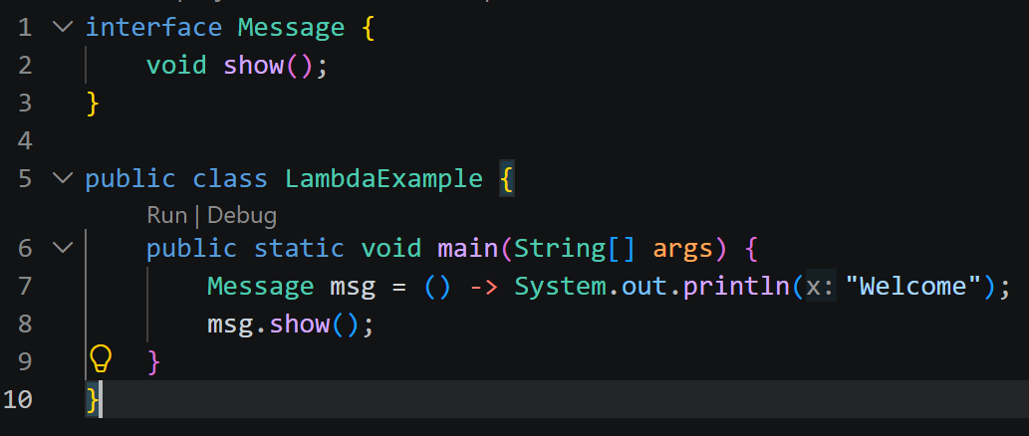

Task 2:

package org.example; in correct
interface Prod{
int multiply(int a, int b);
}
public class Demo034_LambdaExp w{
public static void main(String[] args) {
Prod multiply = (a, b) -> a * b;
int result = Prod.multiply(10, 20);
System.out.println("prod is : " + result);

}
}

Rectified code
package org.example;
interface Math {
int compute(int a, int b);
}
public class Demo034_LambdaExp {
public static void main(String[] args) {
Math multiply = (a, b) -> a * b;
int result = multiply.compute(10, 20);
System.out.println("prod is : " + result);
}
}

Tasks 3:
Wap to create a calc using lambda exp
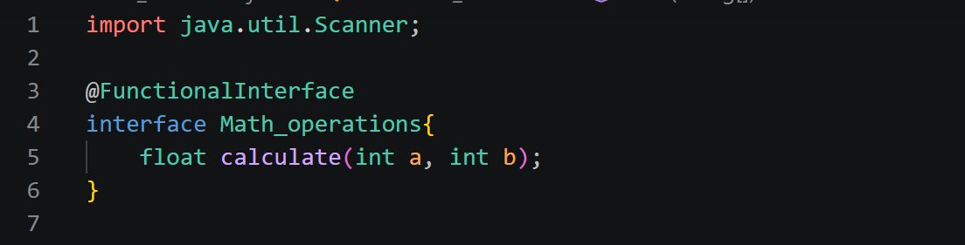

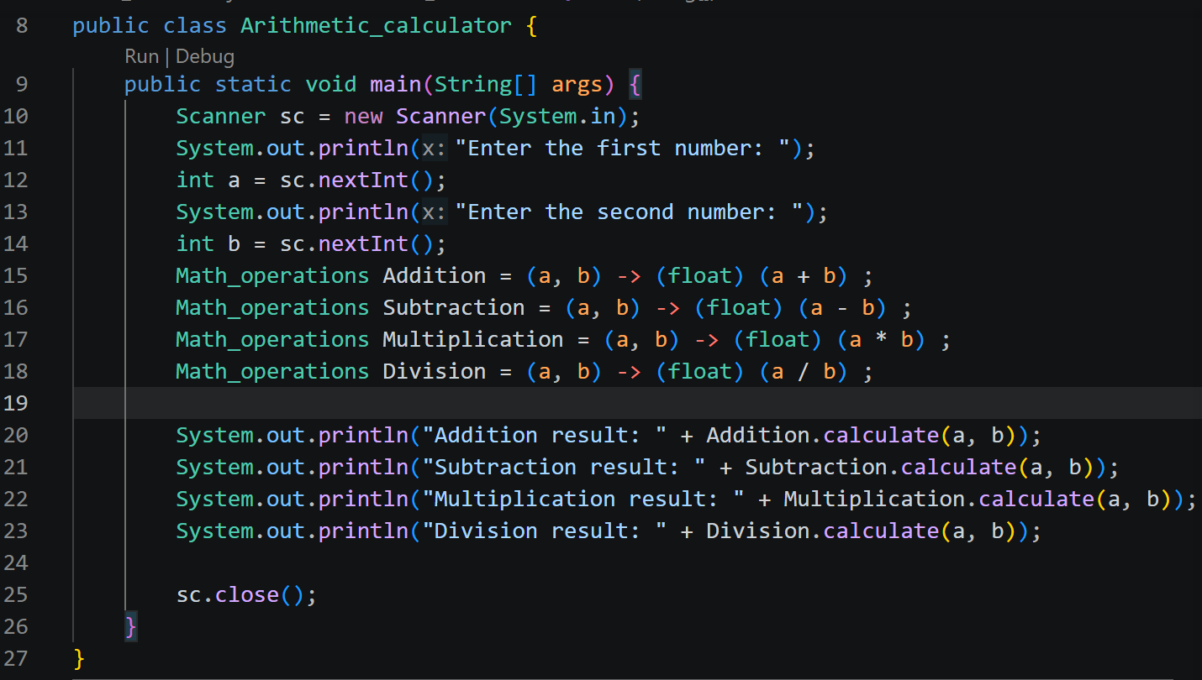

Task 4:
You need to create an interface
- With one abstract method (SAM) and 1 normal method
- can you create 2 normal methods ?
- can i have a method with abstract keyword
Ans :
- yes we can create 2 normal methos with default keyword.
- Yes we can have 1 method as a abstract key word in one interface
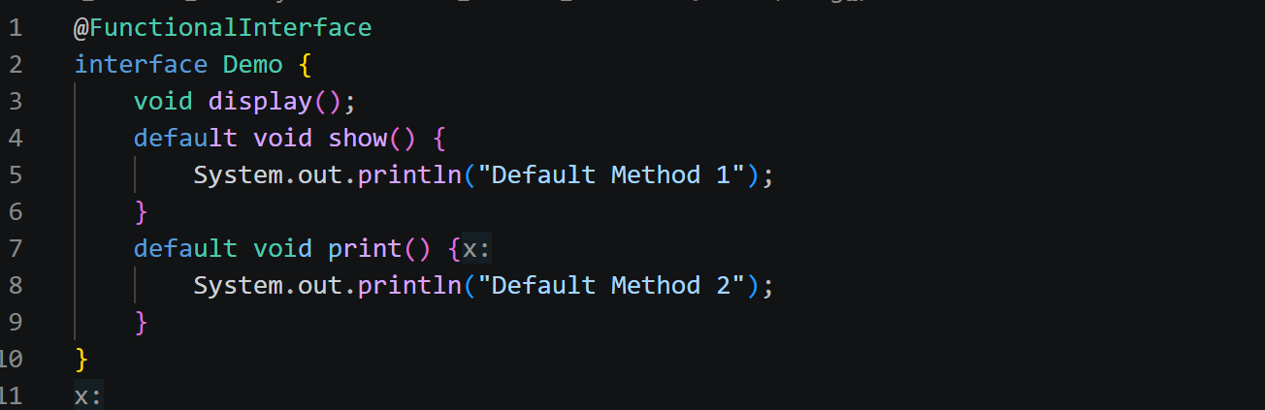
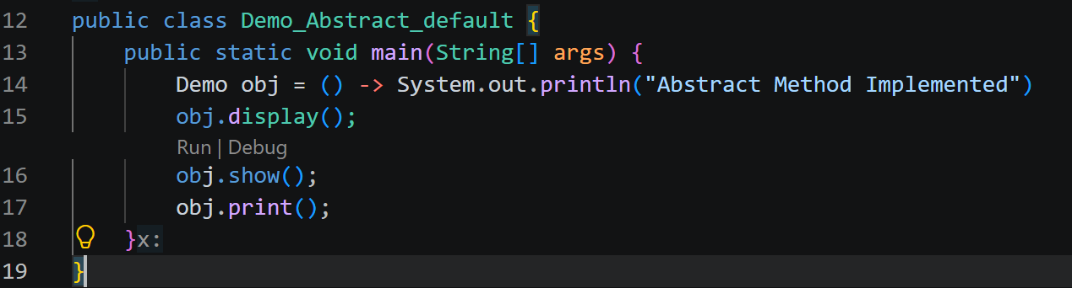

Task 5:

What is this code snippet doing..
Can i have a zero parameter lambda exp or not?
-yes
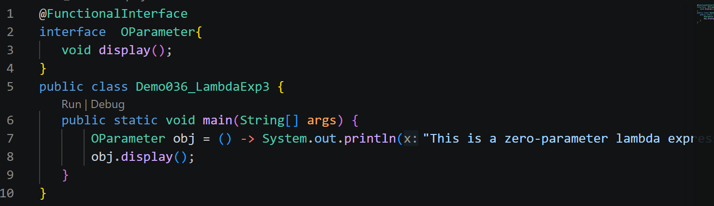

Task 6:
Wap to create an array list
Use lambda exp in foreach
Check if the num is even or odd
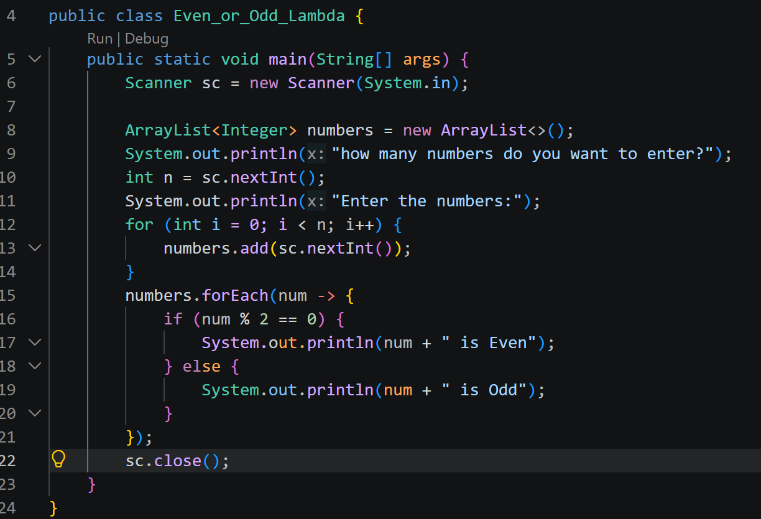

Task 07:
What is Junit 5?
J unit is a testing framework used to write and run the unit test cases to verify that individual parts (units) of their code, such as methods or classes, work correctly.
Task 08:
List down the annotations of Junit 5
@Test, @BeforeEach, @AfterEach, @BeforeAll, @AfterAll, @Disabled, @DisplayName, @ParameterizedTest.

Task 09:
Difference between Junit 5 and Junit 4
JUnit 5 is the newer version of JUnit that provides more features and better support for modern Java applications compared to JUnit 4. JUnit 4 uses older annotations like @Before and @After, while JUnit 5 uses simpler and improved annotations like @BeforeEach and @AfterEach. JUnit 5 also supports better test organization, parameterized testing, and extensions. In simple words, JUnit 5 is more flexible, easy to use, and powerful than JUnit 4.
Task 10:
What is junit Test Suite?
A JUnit Test Suite is a group of multiple test cases combined together and executed as one unit. It helps developers run related tests at the same time, saving time and making testing easier. In simple words, a test suite is a collection of JUnit tests organized in one place for better management.

Task 11:
What is Junit Vintage?
JUnit Vintage is a part of JUnit 5 that allows older JUnit 3 and JUnit 4 test cases to run on the JUnit 5 platform. It helps developers use their existing old tests without rewriting them.

Task 12:
What are mock objects
Mock objects are fake objects used in testing to imitate the behavior of real objects. They help developers test a specific part of an application without depending on external systems or actual objects. In simple words, mock objects make testing easier by providing controlled and predictable test data.

Task 13:
Write about Mockito?
Mockito is a popular Java framework used for creating and working with mock objects in unit testing. It helps developers test code by replacing real dependencies with fake objects and checking their behavior.

Task 14:
Define Functional Interface a java 8 feature
A Functional Interface is a Java 8 feature that contains only one abstract method. It is mainly used with lambda expressions to write cleaner and shorter code.

Task 15:
What are default and static methods in interfaces?
Default and static methods are features introduced in Java 8 that allow interfaces to have method implementations. A default method provides a common implementation that can be inherited by classes, while a static method belongs to the interface itself and can be called directly using the interface name. These methods help add new features to interfaces without affecting existing code.

Task 16:
In Java 8 stream API
import java.util.ArrayList;
import java.util.List;
import java.util.stream.Collectors;

public class Demo039_StreamAPI {
public static void main(String[] args) {
// Creating a List and adding elements
List<String> list = new ArrayList<>();
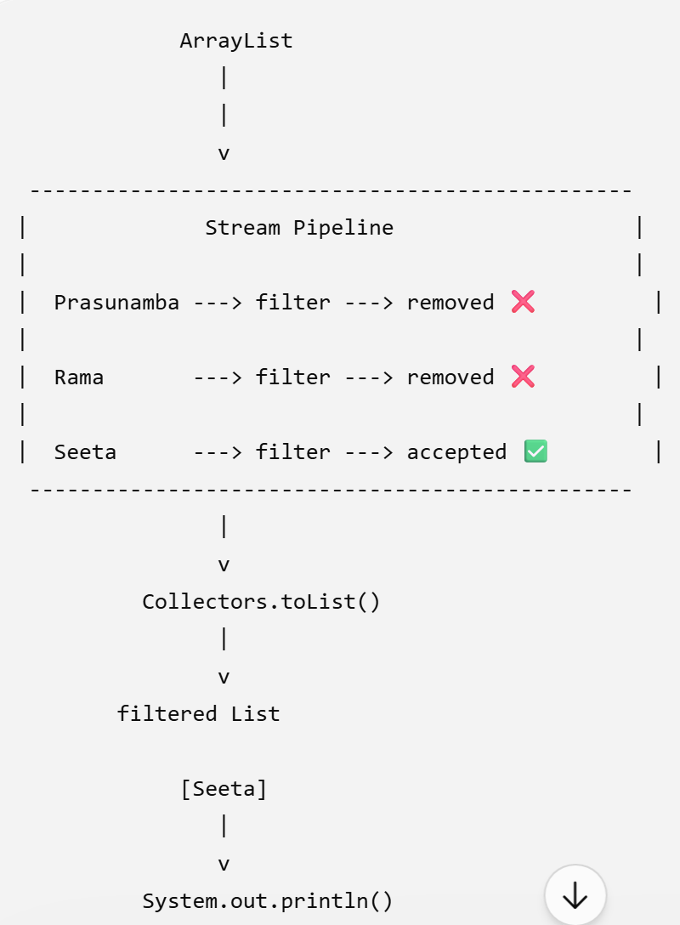
list.add("Prasunamba");
list.add("Rama");
list.add("Seeta");
// Using Stream API to filter names starting with "S"
List<String> filtered = list.stream()
.filter(name -> name.startsWith("S"))
.collect(Collectors.toList());
// Printing the filtered result
System.out.println(filtered);
}
}

Task 17:
What is Optional class in Java 8?
Optional class in Java 8 is a container object that is used to handle null values safely. It helps avoid NullPointerException by providing a better way to check whether a value is present or not

Task 18:
What is error in the below Optional class – which is a feature of java 8?
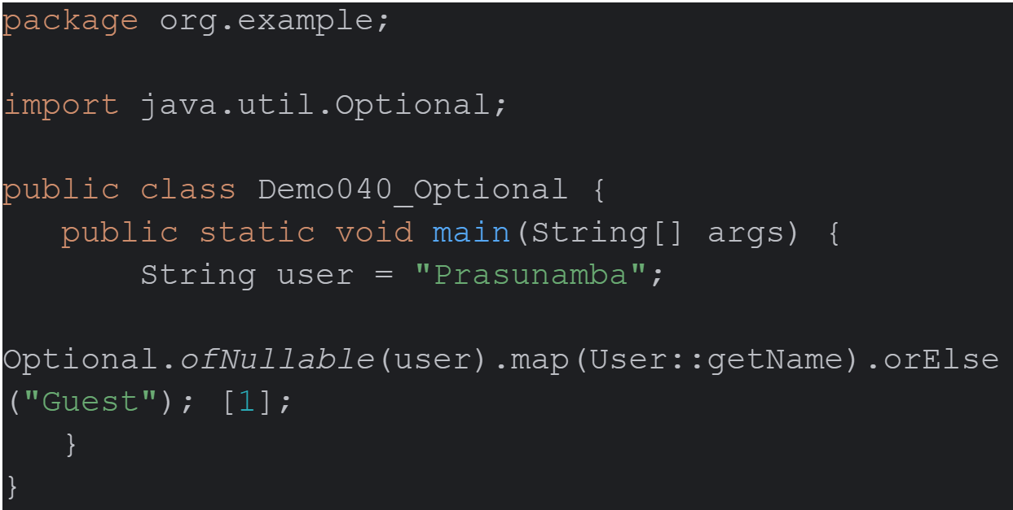
In simple words, the error is caused because the program is trying to call a method from a class (User) that does not exist or does not match the data type of the variable.

Task 19:
What is the double colon :: operator ?
The double colon (::) operator in Java is called the method reference operator. It is used in Java 8 to refer to a method or constructor without calling it directly, and it works with functional interfaces and lambda expressions

Task 20:
What is method Reference in java 8?
Method Reference in Java 8 is a feature that allows a method to be referred to by its name instead of writing a complete lambda expression. It is used with functional interfaces to make the code shorter and easier to read.

